1. **[Auth0](https://auth0.com/" \t "_blank)**

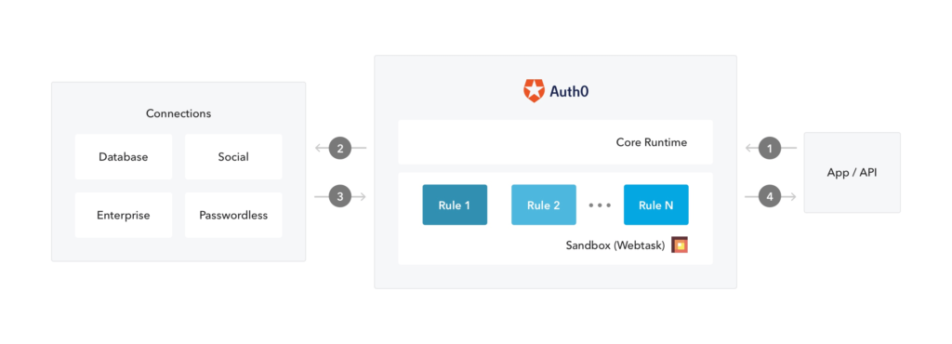

**2. [SpectralOps](https://spectralops.io/" \t "_blank)**

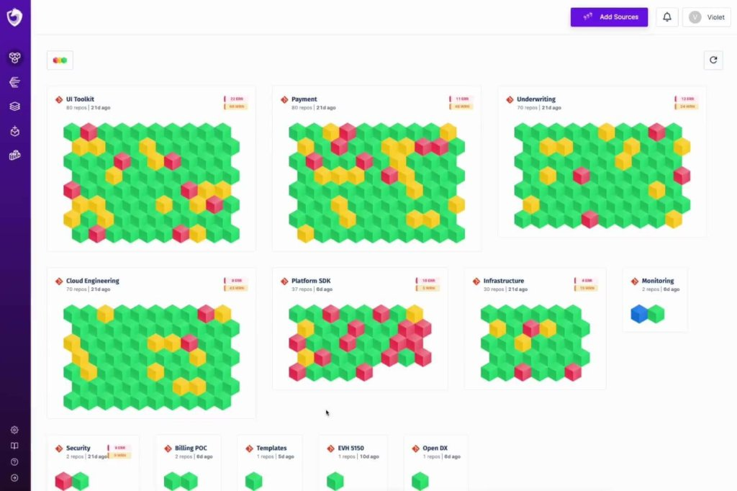

1. [**AWS Identity & Access Management**](https://aws.amazon.com/iam/)

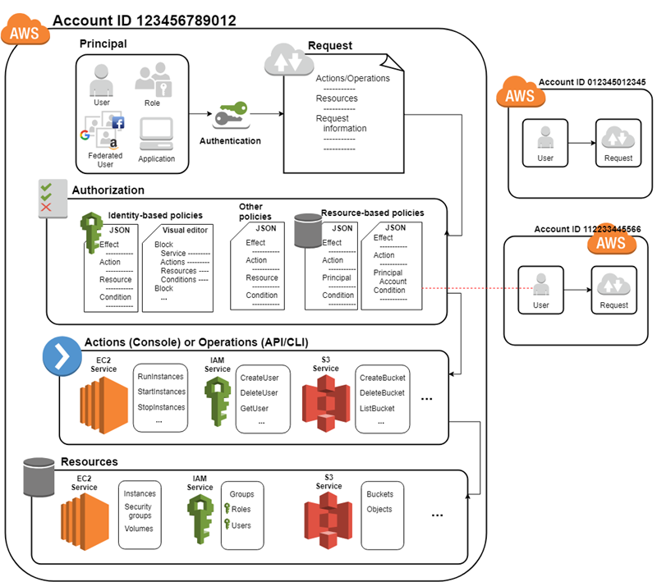

**4.**[**Microsoft Azure Active Directory**](https://azure.microsoft.com/en-us/services/active-directory/)

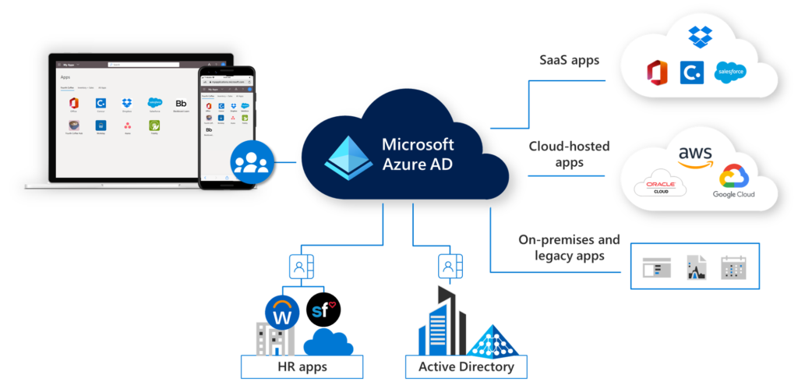

**5.**[**Google Cloud Identity and Access Management (Cloud IAM)**](https://cloud.google.com/iam)

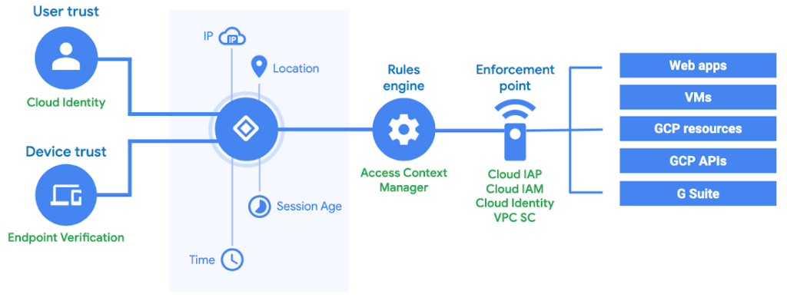

**6.**[**IBM IAM**](https://www.ibm.com/security/identity-access-management)

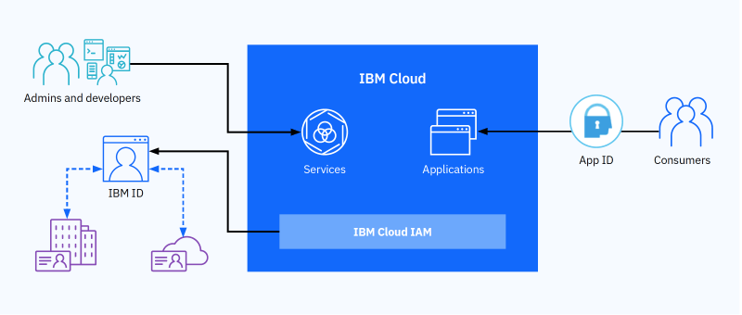

**7.**[**OneLogin**](https://www.onelogin.com/)

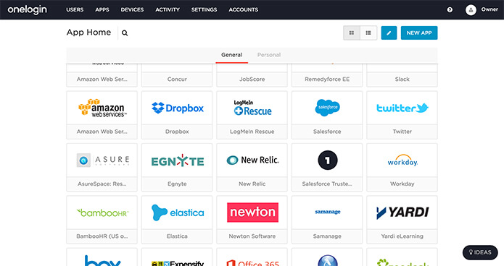

**8.**[**Okta**](https://www.okta.com/)

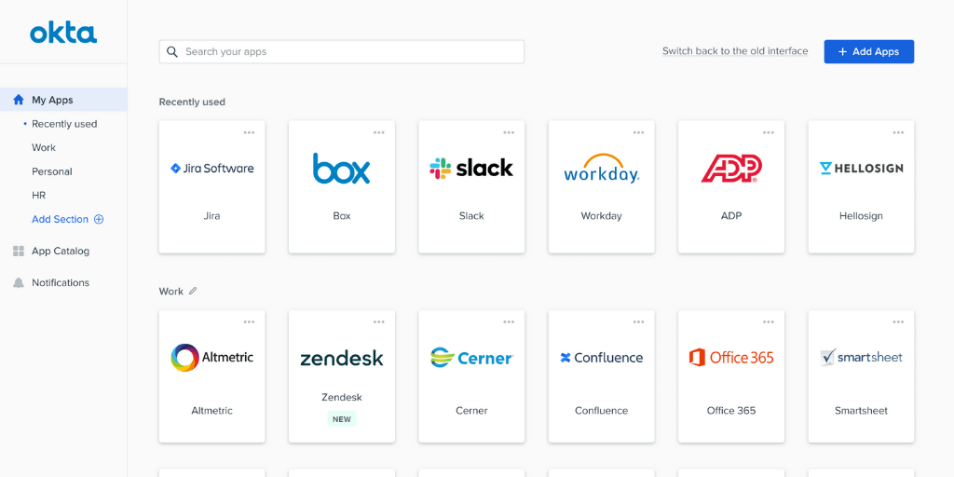

**9.**[**Oracle Identity Management**](https://www.oracle.com/security/identity-management/technologies/)

**10.**[**Ping Identity**](https://www.pingidentity.com/)

